1. **OpenGL Basics**

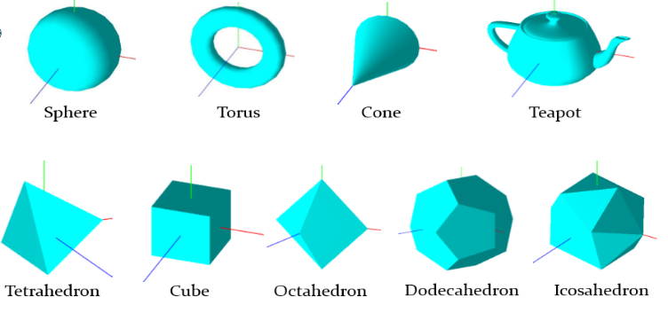

Figure 1 - GLUT Built-in Objects

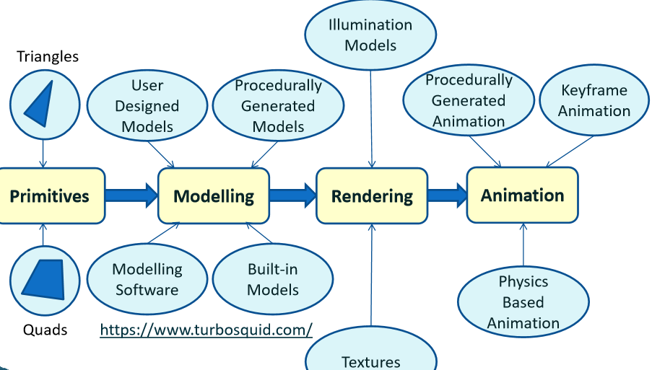

Figure 2 - Basic Pipeline, Models: https://www.turbosquid.com/

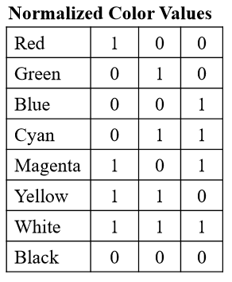

**Geometrical Objects**

Primitive types:

* GL_TRIANGLES, GL_QUADS, GL_TRIANGLE_STRIP, GL_QUAD_STRIP
* Vertices specified = anti-clockwise

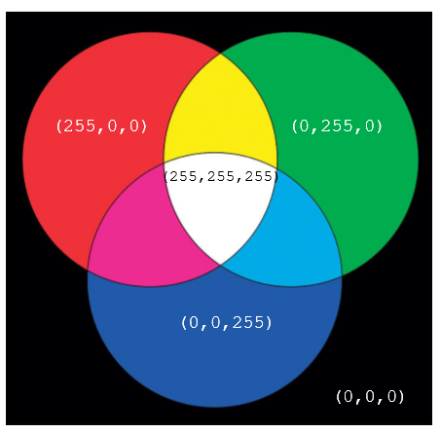

Figure 6 - Additive RGB color space

Mesh formats:

projection mechanism(lens select) = **glFrustum()**, **gluPerspective()**

position = **gluLookAt()**

* OBJ, PLY, **OFF**, DXF, 3DS, MAX, X3D

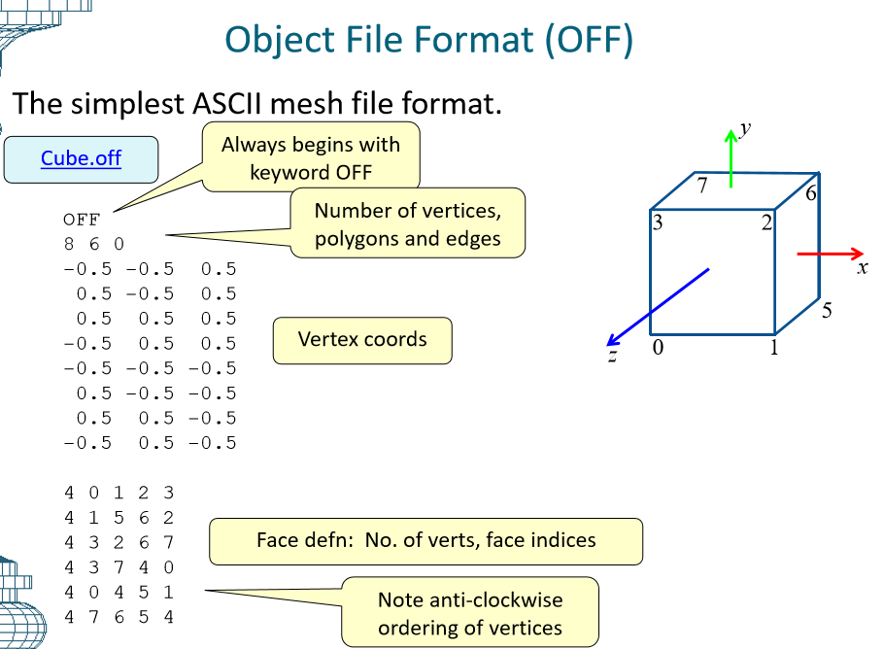

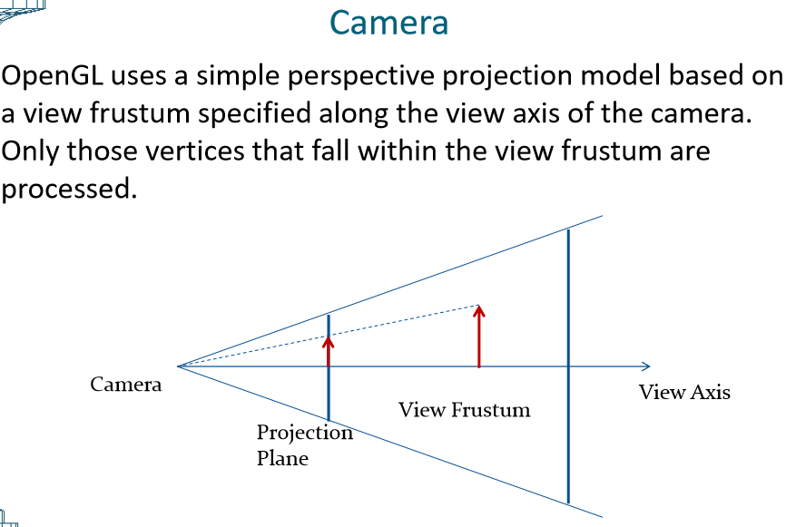

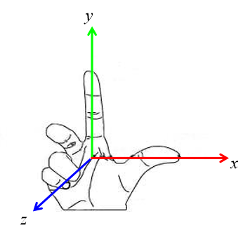

Figure 3 - Coordinate Frame

**Homogeneous Coordinates**

Use = Distinguish between points and vectors - **glVertex4f()**

* 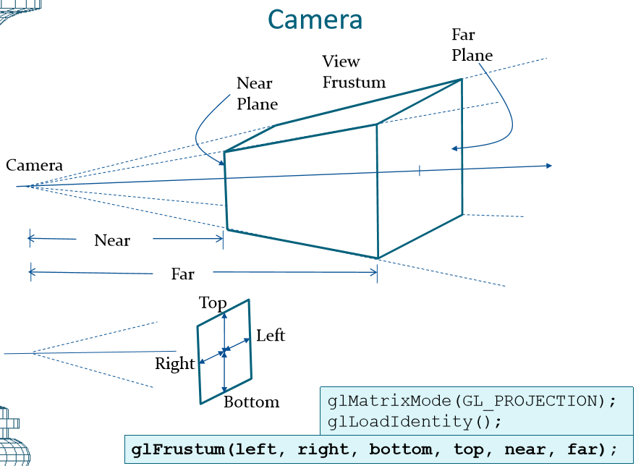Point = glVertex4f (x, y, z, 1)
* Vector = glVertex4f (x, y, z, 0)
* Point/Vector = glVertex3f (4.0, 3.0, 0)

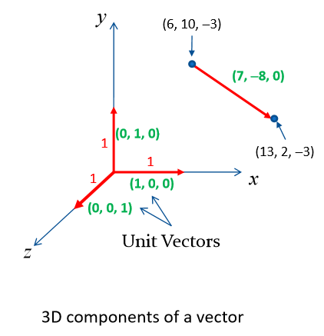

Figure 5 - 3D coordinates of a Vector

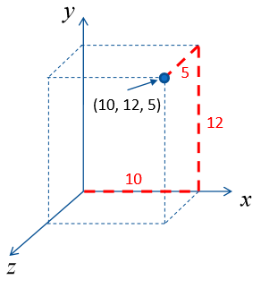

Figure 4 - 3D coordinates of a point

